# Literature Review

**Introduction**

Literature review is nothing but a comprehensive summery of previous research, published magazine of a specific field. Literature review has some objective such as surveying the literature in chosen field, synthesizes the information, critically analyses the information and present the literature information in an organized way. It helps to understand the field that has chosen for the project as well as helps to find out the problems and regarding solution.

**Discussion on Blended Learning:**

At present, Educational System is rapidly changing and it’s now in a transition stage. To cope with this situation

According to the International Journal of Cyber Society and Education, Blended Learning is a combination of traditional learning and e-learning which was defined Cisco Systems in 2001.

<https://www.researchgate.net/publication/221706171_Blended_e-learning_Design_Discussion_of_Cultural_Issues>

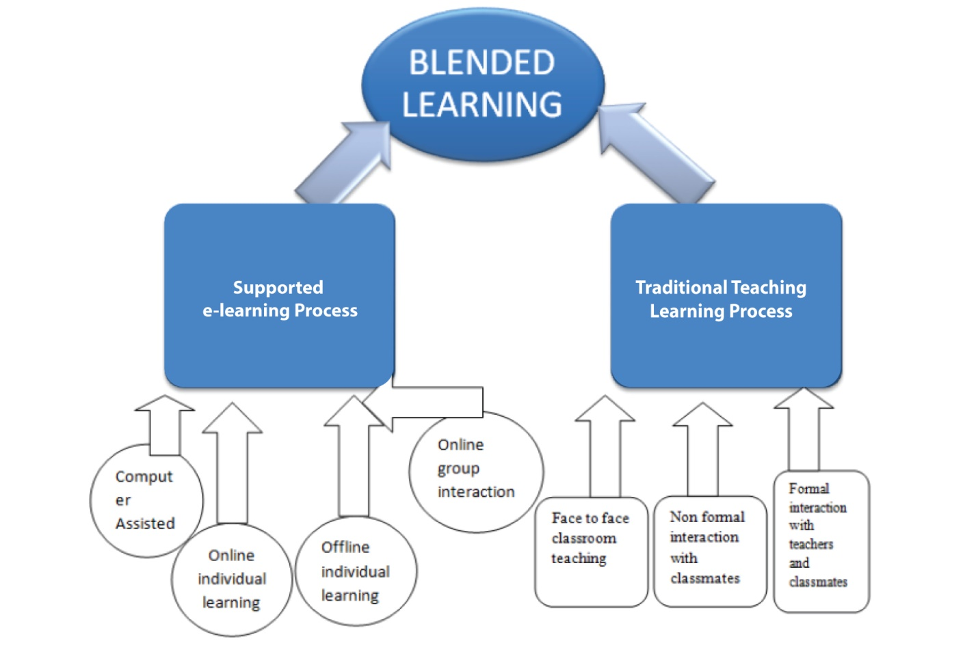

Figure : Structure of Blended Learning